A KAFKAESQUE ELEMENT
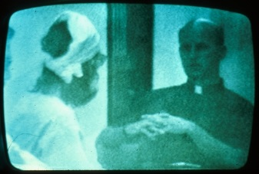
At this point in the study, I invited a Catholic priest who had been a prison chaplain to evaluate how realistic our prison situation was, and the result was truly Kafkaesque. The chaplain interviewed each prisoner individually, and I watched in amazement as half the prisoners introduced themselves by number rather than name. After some small talk, he popped the key question: "Son, what are you doing to get out of here?" When the prisoners responded with puzzlement, he explained that the only way to get out of prison was with the help of a lawyer. He then volunteered to contact their parents to get legal aid if they wanted him to, and some of the prisoners accepted his offer.
The priest's visit further blurred the line between role-playing and reality. In daily life this man was a real priest, but he had learned to play a stereotyped, programmed role so well – talking in a certain way, folding his hands in a prescribed manner – that he seemed more like a movie version of a priest than a real priest, thereby adding to the uncertainty we were all feeling about where our roles ended and our personal identities began.
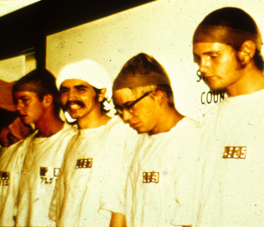
The priest's visit further blurred the line between role-playing and reality. In daily life this man was a real priest, but he had learned to play a stereotyped, programmed role so well – talking in a certain way, folding his hands in a prescribed manner – that he seemed more like a movie version of a priest than a real priest, thereby adding to the uncertainty we were all feeling about where our roles ended and our personal identities began.
#819
The only prisoner who did not want to speak to the priest was Prisoner #819, who was feeling sick, had refused to eat, and wanted to see a doctor rather than a priest. Eventually he was persuaded to come out of his cell and talk to the priest and superintendent so we could see what kind of a doctor he needed. While talking to us, he broke down and began to cry hysterically, just as had the other two boys we released earlier. I took the chain off his foot, the cap off his head, and told him to go and rest in a room that was adjacent to the prison yard. I said that I would get him some food and then take him to see a doctor.
While I was doing this, one of the guards lined up the other prisoners and had them chant aloud: "Prisoner #819 is a bad prisoner. Because of what Prisoner #819 did, my cell is a mess, Mr. Correctional Officer." They shouted this statement in unison a dozen times.
As soon as I realized that #819 could hear the chanting, I raced back to the room where I had left him, and what I found was a boy sobbing uncontrollably while in the background his fellow prisoners were yelling that he was a bad prisoner. No longer was the chanting disorganized and full of fun, as it had been on the first day. Now it was marked by utter confomity and compliance, as if a single voice was saying, "#819 is bad."
I suggested we leave, but he refused. Through his tears, he said he could not leave because the others had labeled him a bad prisoner. Even though he was feeling sick, he wanted to go back and prove he was not a bad prisoner.
At that point I said, "Listen, you are not #819. You are [his name], and my name is Dr. Zimbardo. I am a psychologist, not a prison superintendent, and this is not a real prison. This is just an experiment, and those are students, not prisoners, just like you. Let's go."
He stopped crying suddenly, looked up at me like a small child awakened from a nightmare, and replied, "Okay, let's go."
PAROLE BOARD
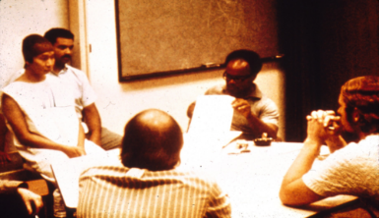
The next day, all prisoners who thought they had grounds for being paroled were chained together and individually brought before the Parole Board. The Board was composed mainly of people who were strangers to the prisoners (departmental secretaries and graduate students) and was headed by our top prison consultant.
Several remarkable things occurred during these parole hearings. First, when we asked prisoners whether they would forfeit the money they had earned up to that time if we were to parole them, most said yes. Then, when we ended the hearings by telling prisoners to go back to their cells while we considered their requests, every prisoner obeyed, even though they could have obtained the same result by simply quitting the experiment. Why did they obey? Because they felt powerless to resist. Their sense of reality had shifted, and they no longer perceived their imprisonment as an experiment. In the psychological prison we had created, only the correctional staff had the power to grant paroles.
During the parole hearings we also witnessed an unexpected metamorphosis of our prison consultant as he adopted the role of head of the Parole Board. He literally became the most hated authoritarian official imaginable, so much so that when it was over he felt sick at who he had become – his own tormentor who had previously rejected his annual parole requests for 16 years when he was a prisoner.
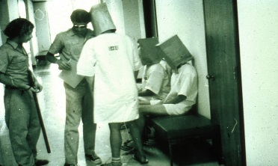
TYPES OF GUARDS
By the fifth day, a new relationship had emerged between prisoners and guards. The guards now fell into their job more easily – a job which at times was boring and at times was interesting.
There were three types of guards. First, there were tough but fair guards who followed prison rules. Second, there were "good guys" who did little favors for the prisoners and never punished them. And finally, about a third of the guards were hostile, arbitrary, and inventive in their forms of prisoner humiliation. These guards appeared to thoroughly enjoy the power they wielded, yet none of our preliminary personality tests were able to predict this behavior. The only link between personality and prison behavior was a finding that prisoners with a high degree of authoritarianism endured our authoritarian prison environment longer than did other prisoners.
JOHN WAYNE
The prisoners even nicknamed the most macho and brutal guard in our study "John Wayne." Later, we learned that the most notorious guard in a Nazi prison near Buchenwald was named "Tom Mix" – the John Wayne of an earlier generation -- because of his "Wild West" cowboy macho image in abusing camp inmates.
Where had our "John Wayne" learned to become such a guard? How could he and others move so readily into that role? How could intelligent, mentally healthy, "ordinary" men become perpetrators of evil so quickly? These were questions we were forced to ask.
PRISONERS' COPING STYLES
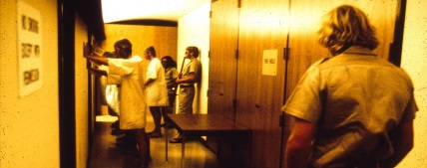
Prisoners coped with their feelings of frustration and powerlessness in a variety of ways. At first, some prisoners rebelled or fought with the guards. Four prisoners reacted by breaking down emotionally as a way to escape the situation. One prisoner developed a psychosomatic rash over his entire body when he learned that his parole request had been turned down. Others tried to cope by being good prisoners, doing everything the guards wanted them to do. One of them was even nicknamed "Sarge," because he was so military-like in executing all commands.
ONE FINAL ACT OF REBELLION
We did see one final act of rebellion. Prisoner #416 was newly admitted as one of our stand-by prisoners. Unlike the other prisoners, who had experienced a gradual escalation of harassment, this prisoner's horror was full-blown when he arrived. The "old timer" prisoners told him that quitting was impossible, that it was a real prison.
Prisoner #416 coped by going on a hunger strike to force his release. After several unsuccessful attempts to get #416 to eat, the guards threw him into solitary confinement for three hours, even though their own rules stated that one hour was the limit. Still, #416 refused.
At this point #416 should have been a hero to the other prisoners. But instead, the others saw him as a troublemaker. The head guard then exploited this feeling by giving prisoners a choice. They could have #416 come out of solitary if they were willing to give up their blanket, or they could leave #416 in solitary all night.
What do you think they chose? Most elected to keep their blanket and let their fellow prisoner suffer in solitary all night. (We intervened later and returned #416 to his cell.)
AN END TO THE EXPERIMENT
On the fifth night, some visiting parents asked me to contact a lawyer in order to get their son out of prison. They said a Catholic priest had called to tell them they should get a lawyer or public defender if they wanted to bail their son out! I called the lawyer as requested, and he came the next day to interview the prisoners with a standard set of legal questions, even though he, too, knew it was just an experiment.
At this point it became clear that we had to end the study. We had created an overwhelmingly powerful situation -- a situation in which prisoners were withdrawing and behaving in pathological ways, and in which some of the guards were behaving sadistically. Even the "good" guards felt helpless to intervene, and none of the guards quit while the study was in progress. Indeed, it should be noted that no guard ever came late for his shift, called in sick, left early, or demanded extra pay for overtime work.
I ended the study prematurely for two reasons. First, we had learned through videotapes that the guards were escalating their abuse of prisoners in the middle of the night when they thought no researchers were watching and the experiment was "off." Their boredom had driven them to ever more pornographic and degrading abuse of the prisoners.
Second, Christina Maslach, a recent Stanford Ph.D. brought in to conduct interviews with the guards and prisoners, strongly objected when she saw our prisoners being marched on a toilet run, bags over their heads, legs chained together, hands on each other's shoulders. Filled with outrage, she said, "It's terrible what you are doing to these boys!" Out of 50 or more outsiders who had seen our prison, she was the only one who ever questioned its morality. Once she countered the power of the situation, however, it became clear that the study should be ended.
And so, after only six days, our planned two-week prison simulation was called off.
On the last day, we held a series of encounter sessions, first with all the guards, then with all the prisoners (including those who had been released earlier), and finally with the guards, prisoners, and staff together. We did this in order to get everyone's feelings out in the open, to recount what we had observed in each other and ourselves, and to share our experiences, which to each of us had been quite profound.
We also tried to make this a time for moral reeducation by discussing the conflicts posed by this simulation and our behavior. For example, we reviewed the moral alternatives that had been available to us, so that we would be better equipped to behave morally in future real-life situations, avoiding or opposing situations that might transform ordinary individuals into willing perpetrators or victims of evil.

