Resource 1.3
Myths and Mythology
Adapted from Holt Literature & Language Arts, Third Course
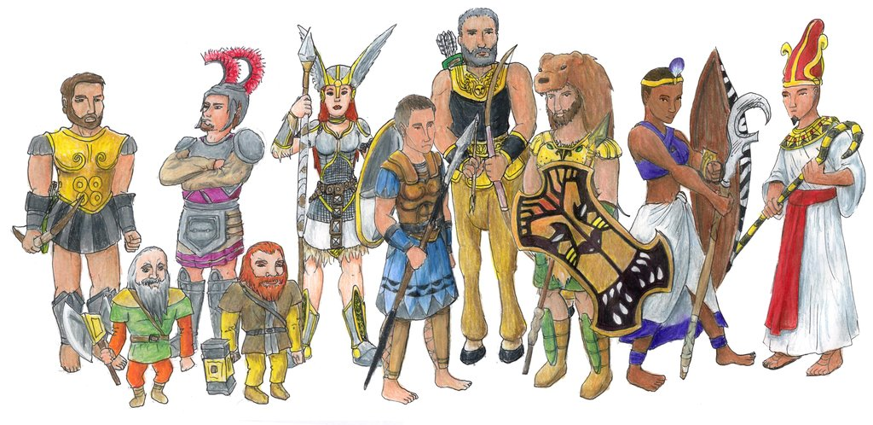
Every culture has its myths: stories that are connected to the region, traditions, or belief systems of the culture that produced them. Myths tell people where they came from, where they are going, or how they should live. Myths predate science; therefore, they provide imaginative explanations for the origins of things. They answer questions like, “Why is there evil in the world?” or “Why do we die?” or “Why do the seasons change?”

Most myths grew out of belief system rituals, and almost all of them involve the influence of “gods” on human affairs. Myths are narratives, which are built on a series of causes and effects. One event happens in a myth, which causes another event to happen, and so on. The term mythology can refer either to a collection of myths or to the study of myths.

Many archetypes come from myths. Archetypes are very old patterns or images that recur over and over again in literature. Archetypes can be characters (such as the sacrificial hero), plots (such as the heroic quest), animals (such as lambs, wolves, and serpents), or settings (such as the place of perfect happiness). Myths also follow patterns in the use of symbols like colors and circles.

