Resource 3.1

“How do myths reflect our cultural beliefs and values?”
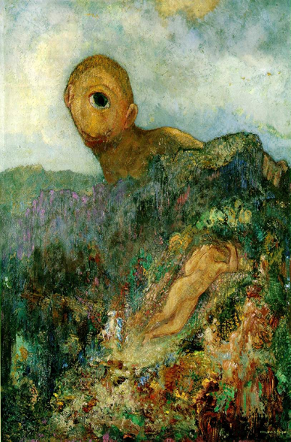
Look at the painting. Use adjectives to describe the Cyclops’s traits.

